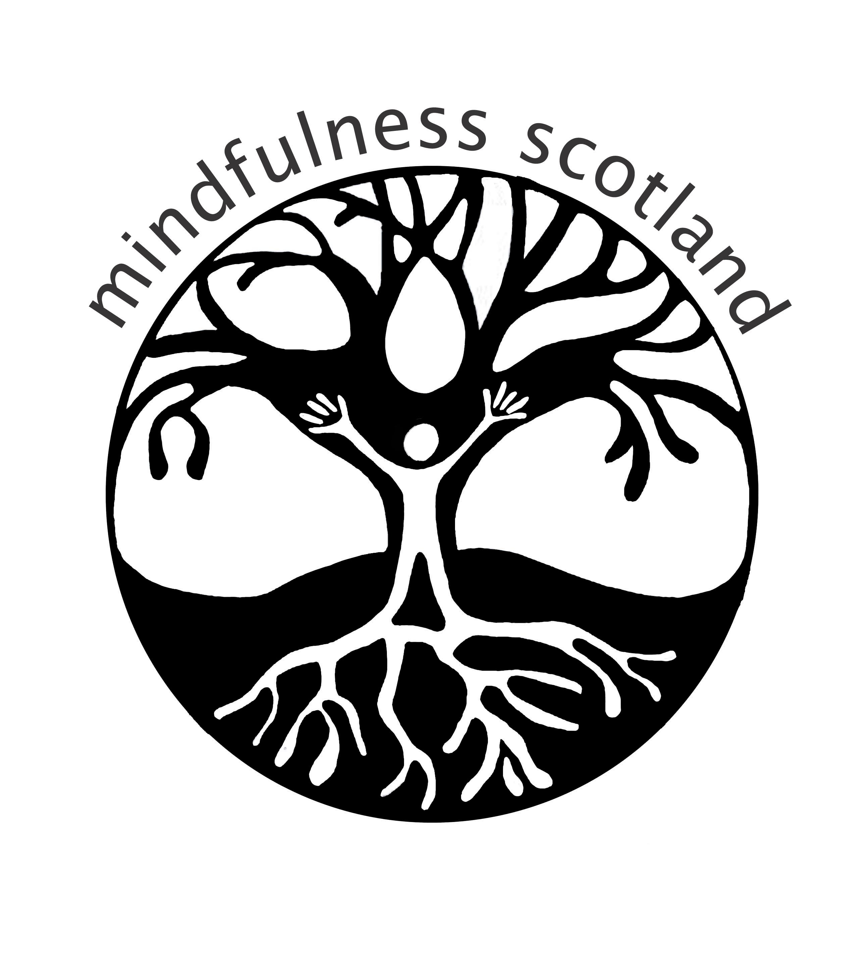
Mindfulness Scotland

Mindfulness Teacher Development Retreat

Holy Island, Isle of Arran

Wednesday June 10th – Tuesday June 16th 2009

facilitated by

Charlotte Procter, Ratnadevi, Laura Steckler

This is an experiential training opportunity conducted in the context of a nourishing retreat on this beautiful and peaceful island. It is suitable for health professionals who have completed an eight-week mindfulness course in mindfulness based approaches for health (MBSR or MBCT) or its equivalent, and who have a fairly well established mindfulness practice, or are in the process of establishing one. It is for those professionals who are at an early stage of development in the application of mindfulness-based approaches in their work and who wish to build their understanding, practice and confidence in the use of these approaches in clinical settings. It is also for those who wish to deepen their personal practice of mindfulness meditation and refresh their teaching skills in the context of a growing network of mindfulness practitioners in healthcare in Scotland.

During the retreat we will be re-visiting the core practices and curriculum of Mindfulness Based Cognitive Therapy and Mindfulness Based Stress Reduction. There will be a particular emphasis upon mindful movement, with two highly experienced practitioners in the field. There will be ample opportunity for personal space and reflection, and opportunities to explore the practices deeply and the rationale behind them. We will focus upon the skills required in teaching and leading components of the curriculum, with opportunities to lead practices and enquire into co-participant’s experiences of these, in a space which feels safe and accepting. On the retreat there will be periods of silence and the experience of living together as a community.

The cost for accommodation includes a daily fee for the Peace Hall, where we will be conducting the course and three vegetarian meals per day. There are three different rates: £300 for a single room, £225 per person for a double room, £180 per person for a dormitory room (which accommodate up to 8 people in single sex rooms).

In addition, there will be a course fee of £240 for the week (*).

For further information about this course, contact Charlotte Procter on charlotte.procter@nhslothian.scot.nhs.uk (0131 537 6799). Contact Holy Isle for any information required concerning accommodation, dietary requirements, travel, etc.

For booking, please send the application form to Charlotte Procter, with the course booking fee of £240 (cheques can be made out to Mindfulness Scotland). Once you have a confirmed place on the course (Charlotte will confirm this with you) you can organise your accommodation, by contacting the Holy Island team, on 01770 601100 or by email on reception@holyisland.org. When you book, Holy Island will ask for a £50 deposit. The remaining accommodation fee can be paid on arrival at Holy Island.

(*) We are aware that this fee is higher than in previous years. We have been operating on a voluntary basis thus far which is not sustainable. This fee represents the quality of the course and is in line with other similar programmes.

The Facilitators

Dr. Charlotte Procter has 15 years post-qualification experience as a Clinical Psychologist, working in Specialist Services since 1997 in NHS Lothian. She has experience of applying mindfulness approaches with patients with complex disorders, including eating disorders, trauma and borderline personality disorder. She has been involved in the training of mental health staff in mindfulness and meditation techniques and has experience teaching meditation in prison settings. She trained in Dialectical Behaviour Therapy in 1997, and has been involved in its application, adaptation and teaching for a range of professionals working with patients who self-harm. She has run Mindfulness groups for patients and staff since 2001, and facilitates a follow-on interest group. She has practised Buddhist meditation and mindfulness for 14 years, and has received instruction in meditation techniques from a variety of traditions, including Thich Nhat Hanh. She has engaged in the Practicum in Mindfulness Based Stress Reduction, at the University of Massachusetts Medical School and was involved in facilitating the mindfulness training for mental health staff in the Scottish Executive funded project, “Doing Well by People with Depression” .

Ratnadevi (Luise Holtbernd, PhD) is a member of the Western Buddhist Order and has been teaching Yoga and Meditation for 20 years, both in Glasgow and at various retreat centres. She has been facilitating MBCT courses and retreats since 2004 and has been involved in training NHS professionals, with an emphasis on mindful movement. She is also a visual artist and ecologist (see www.bodhi-eco-project.org ) and seeks to bring an attitude of playful enquiry to all aspects of her work. www.ratnadevi2.talktalk.net

Laura Hope Steckler, Ph.D. C.R.S., R.S.M.T. is a Clinical psychologist, somatic movement therapist, body-psychotherapist, yoga practitioner, dancer and mindfulness instructor. American born and trained, she now lives and works in the Scottish Borders and Edinburgh, specialising in chronic pain. She has been a practicing meditator for over 30 years but still considers herself a beginner. She is a certified practitioner of Rubenfeld Synergy®, a method of body-orientated psychotherapy that integrates the Alexander technique and Feldenkrais method with humanistic and psychodynamic psychotherapy. Her interest in mindfulness is supported by her love of movement and her deep and passionate interest in the interface between body, mind and spirit.

Accommodation and Location

For more information about the venue and travelling arrangements, please look at the Holy Island website on www.holyisland.org or speak to Holy Isle Reception staff on 01770 601100, e-mail reception@holyisland.org

Postal address: Holy Isle, Lamlash P.O., Lamlash, Isle of Arran, KA27 8GB.

Mindfulness Teacher Development and Deepening Practice Retreat

Holy Island, Isle of Arran

June 10th – June 16th 2009

Please book me a place on the above retreat.

Name:

Profession:

Postal address:

Telephone number: Email address:

Previous experience of mindfulness based approaches in care settings including courses attended or facilitated (please describe):

Previous experience of mindfulness practice including retreats, courses etc. (please describe):

I enclose a cheque for £240 to cover course fees (Please make cheques payable to “Mindfulness Scotland” and send to Charlotte Procter).

Return to Charlotte Procter, Clinical Psychologist, Cullen Centre, Tipperlinn Road, Royal Edinburgh Hospital, Edinburgh EH10 5HF.

ONCE CHARLOTTE HAS CONTACTED YOU TO CONFIRM YOUR PLACE ON THIS RETREAT, PLEASE CONTACT HOLY ISLAND TO BOOK ACCOMMODATION (INCLUDES MEALS).

