the fight, flight & freeze circuits

As individuals, we are oriented toward seeking our own well-being. Hence we tend to approach new resources, in hope of finding a reward in them for this behaviour. But in some situations, our past experiences may have taught us that such pleasure-seeking behaviour might be punished. Our other behavioural options then include fight or flight (two ways of eliminating dangers that threaten the body’s integrity) or inhibiting our behaviour so as to go unnoticed and thus avoid confrontation. One can easily imagine the adaptive value of behavioural inhibition. Suppose a mouse scurrying through the grass suddenly notices a buzzard flying overhead. Out of fear, the mouse freezes in place, and so does not attract the buzzard’s attention. Thus, playing dead until a predator has passed can be beneficial, as long as the tension of waiting does not go on for too long.

The following diagram shows how we choose optimal behaviours and some of the brain structures involved in this process. This diagram also shows the feedback loops present throughout this process, whereby our memories let us associate positive or negative connotations with situations that we experience, then adjust our behaviour accordingly the next time they arise.

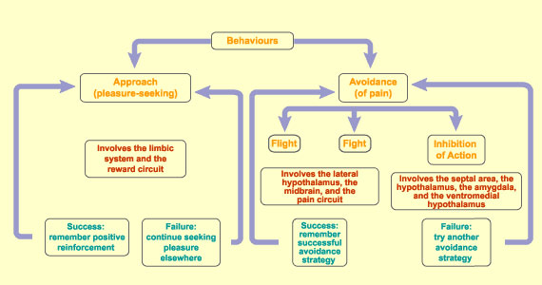

But this whole process falls apart if, for example, you’re not a mouse hiding from a buzzard, but a worker who has to deal with a boss who is exploiting you. You cannot fight or flee, or you would be out of a job. So you let months and years go by while you inhibit your own behaviour. This can ultimately have disastrous effects on your health. For one thing, such inhibition causes hormonal changes that produce high blood levels of gluticocorticoids, whose depressive effect on immune system function is well known. This weakening of the immune system is why remaining in a state of behavioural inhibition for too long can open the door to all kinds of pathologies.

Another situation that can inhibit behaviour is a shortage of information. To behave effectively, you need a certain amount of information about the world. If you have not acquired enough information from your past experiences, or if you cannot access this information, you may be stuck and not know how to act. That is why some people freeze up when they have to deal with a computer, or when they are confronted with death. But too much information can have the same effect. Especially in modern societies, we are flooded with information from all directions–snatches of information taken out of context from news broadcasts, the ceaseless torrent of advertising messages, and so on. We have not learned how to slot all this information into the appropriate levels in our knowledge hierarchy, so we may feel helpless to act on it. One final source of inhibition is our imagination, that quintessentially human faculty, which can make us foresee so many potentially negative scenarios that we end up doing nothing. For example, the prospect of rejection has kept more than one ardent Romeo from declaring himself to his beloved.

see Canadian Institutes of Health Research & Neurosciences wonderful website www.thebrain.mcgill.ca and click through to ‘anatomy & function: function by level of organization: psychological/advanced’

